**SYSTEM ANALYSIS AND DESIGN**

**CLASS ACTIVITY – ( 20 Marks )**

**Pruthvirajsinh Zala (B4-67,16,42)**

Prepare following diagram using Ms. Visio after proper analysis of the current business system. You need to visit the business site and apply fact finding techniques.

1. Visit any business of your choice of your own (or your relatives). -Crystal Mall
2. Prepare Use case diagram. ( 2 marks )

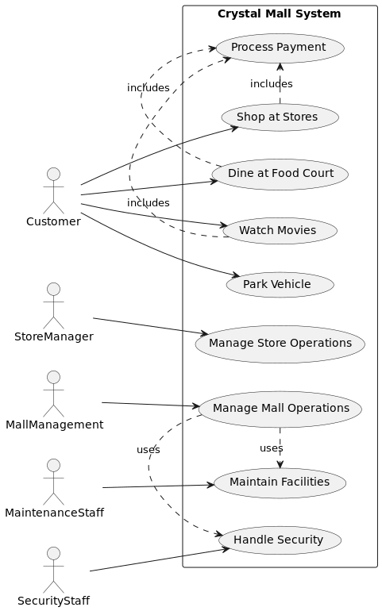

Draw Organization chart of your proposed system to determine

subsystem, components, and modules in your system. ( 2 marks )

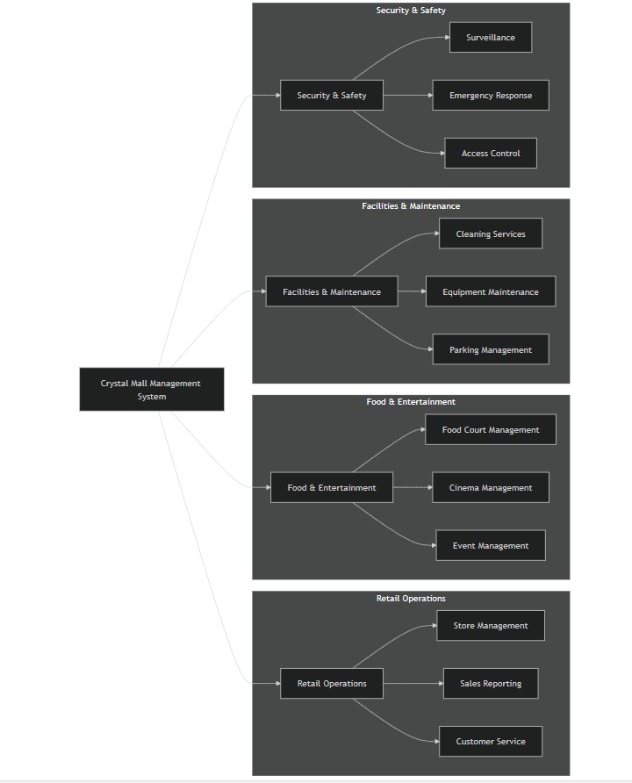

Prepare following three lists. ( 1 marks )

a. Process

b. Tables

c. External Entities

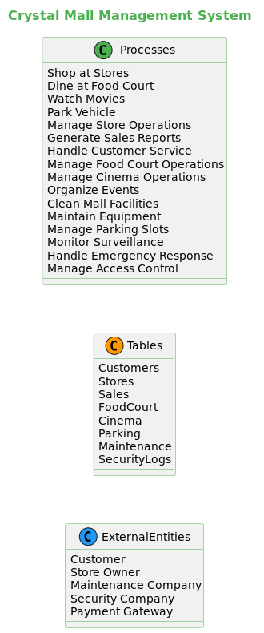

Draw context Diagram.



Draw 0-level DFD. (Draw 1st and 2nd level if required for any process).

( 4 marks )



Draw Database Model Diagram (of 4b). ( 3 marks )

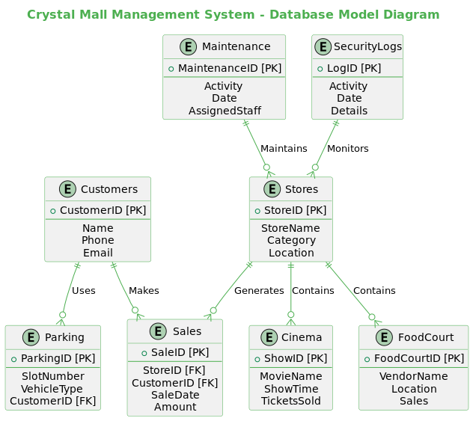

Draw Activity Diagram as many as required. ( 3 marks )

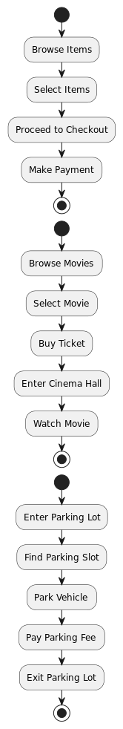

Write algorithm / Draw flow chart for any two module (3) or any two

process (4a). ( 4 marks )

